FOOD DELIVERY MANAGEMENT SYSTEM

ASSIGNMENT 4

NUME STUDENT: Voicu Sara-Ioana
GRUPA: 30421

CHAPTERS

1. Objectives 3
2. Analyzing the problem and Use-Cases 3
3. Design 4
4. Implementation 8
5. Results 9
6. Conclusion 9
7. Bibliography 10

Objectives
The main purpose of this project is to design and implement a food delivery management system for a catering company. The client can order products from a company’s menu. We have 3 types of users that can log in using a username and a password: administrator, client and employee.
Other sub-objectives are:
- Analyzing the problem and the requirements
- Designing the graphical interfaces of the application
- Implementing each task that the users can do

Analyzing the problem and Use-Cases
Analyzing the problem:

Each user has some specific roles:
ADMINISITRATOR:
-import the initial set of products
-add products to the menu
-delete products from the menu
-modify products from the menu
-create new products that represent a combination of several menu products
-generate reports based on: time interval of the orders, the products ordered more than a specified number of times, the clients that have ordered more than a specified number of times so far and the value of the order was higher than a specified amount, the products ordered within a specified day with the number of times they have been ordered
CLIENT:
-register and user the registered username and password to log in within the system
-view the list of products from the menu
-search for products based on one or multiple criteria such as keywords, rating, number of calories/protein/fats/sodium/prices
-create an order consisting of several products – for each order the date and time will be persisted, and a bill will be generated that will list the ordered products and the total price of the order

Modelling the problem:

Use Case 1: register and log in
Primary Actor: user
Main Success Scenario: the user is able to register as a client. Then he/she can log in as an administrator, employee and client, depending on the username and password. For the administrator and employee the username and password are already set.

Use Case 2: add, delete, modify and create items
Primary Actor: user(administrator)
Main Success Scenario: the user, as an administrator, is able to add, delete, modify and create new items that he/she can add to the menu.

Use Case 3: generate reports
Primary Actor: user(administrator)
Main Success Scenario: the user, as an administrator, is able to generate reports based on different orders and conditions that I specified in the description of the project.

Use Case 4: search items in the menu
Primary Actor: user(client)
Main Success Scenario: the user, as a client, is able to search based on different keywords or based on calories/protein/price all the items that respect that specified condition

Use Case 5: create orders and see the bill in a text file
Primary Actor: user(client)
Main Success Scenario: the user, as a client, is able to create orders that contain one or more items for the menu and he/she can also see the bill that is generated in a text file

The diagram of the Use-Cases:

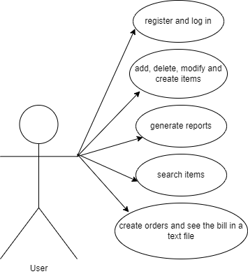

Design
The class diagrams are used in designing and modelling the software. The diagrams describe the classes and their relationships. They enable us to model software in a high level of abstraction and without having to look at the source code. The classes are described by including the attributes, objects and the methods from a specific class. On top we have the name of the class and below it the attributes. A minus in front of the attribute means that the attribute is private. The constructors, getters, setters and methods are listed below the attributes.
What are the benefits of UML diagrams? They are very flexible and easy to draw, and in this way, you can communicate the software architecture effectively.

The UML Diagram:

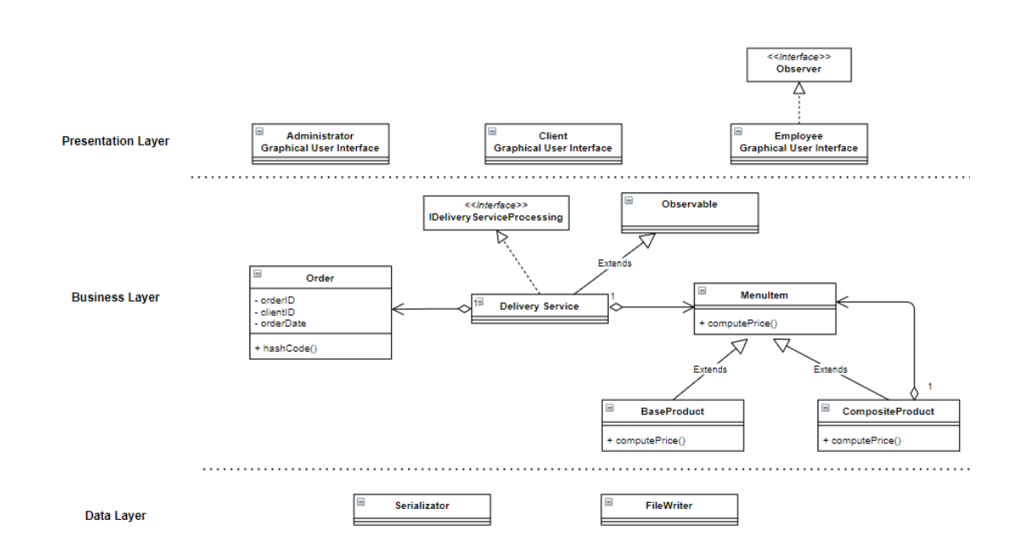

Data structures: The data structures used in this project are mostly primitive types, especially integers and strings, but also complex types such as ArrayList type objects, Lists or Maps.
The lists were used for storing new created objects such as MenuItem or Qrder type of objects. ArrayLists are more efficient regarding the memory management, performance and provide a faster access to their content than regular arrays.
An important data structure used in this project is Hashing. Hashing is a technique or process of mapping keys, values intro the hash table by using a hash function. It is done for faster access to elements. The efficiency of mapping depends on the efficiency of the hash function used.
Hash Table:
-backing data structure for HashSet, LinkedHashSet, HashMap, HashTable etc.
-used to implement an associative array (by mapping keys to values) with constant access time to its elements
-the keys will be used as indexes in an array

Packages: A package in Java is used to group related classes. They are used in order to avoid name conflicts and to write a better maintainable code. The project is organized in 4 packages: application, controller, businessLayer and presentationLayer.
Application: contains a single class that has the customary main() method.
Controller: It works on both the model and view. It is used to manage the flow of application, i.e. data flow in the model object and to update the view whenever data is changed. The controller package contains:
- the Controller class : makes the connection between the 4 interfaces and the connections on the main interface (LoginInterface)
-the Serializator class: for serializing and deserializing the data from the DeliveryService class
-the FileWriter class: a class that contains a method that generates the bill in a text file bill.txt whenever the client orders something
BussinessLayer: a package that contains the classes BaseProduct, CompositeProduct, MenuItem, Order, User, NewDate,, DeliveryService and the Interface IdDeliveryServingProcessing
PresentationLayer: a package that contains all the interfaces as classes: LoginInterface, AdministratorInterface, ClientInterface and ObserverInterface

The Graphical Interfaces:
LoginInterface:
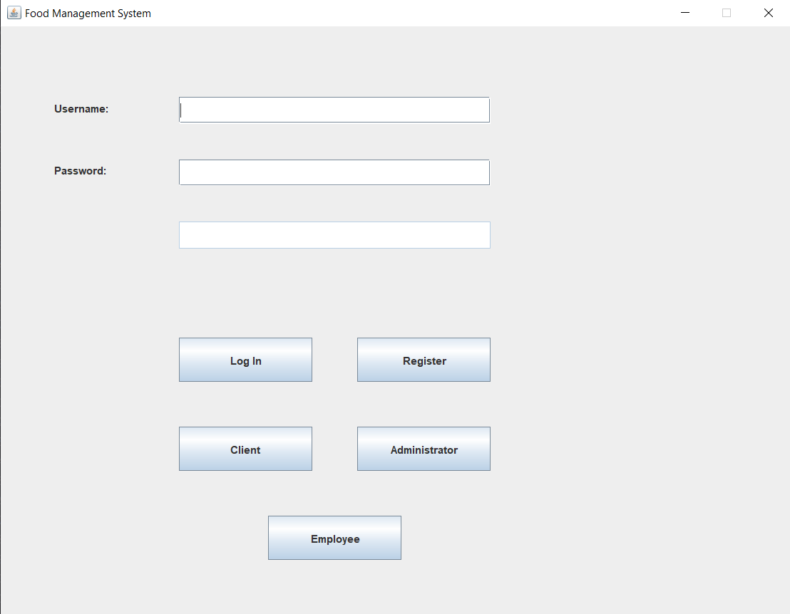

It extends the JFrame class and displays:
- 2 text fields for the user to introduce the username and passwords
-1 text field to display a message in case of an error
-1 button to log in, 1 button to register, 1 button for the client interface, 1 button for the employee interface, 1 button for the administrator interface

AdministratoInterface:
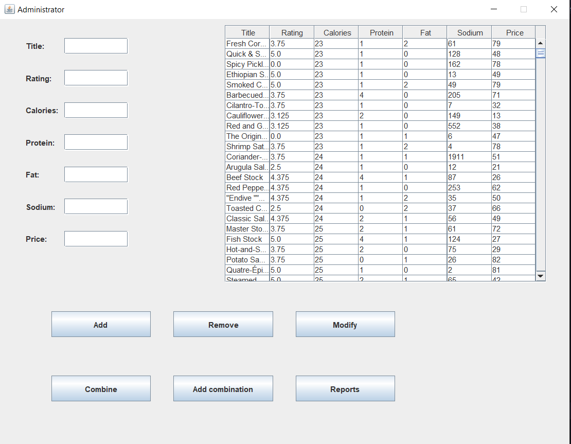
It extends the JFrame class and displays:
-7 text fields to introduce the data in order to add, modify or create a new item
-1 button to add an item, 1 button to remove an item, 1 button to modify an item, 1 button to combine, 1 button to add a product to the combination and 1 button to see the reports
-1 table that contains all the items (the menu) imported from the products.csv file

ClientInterface:
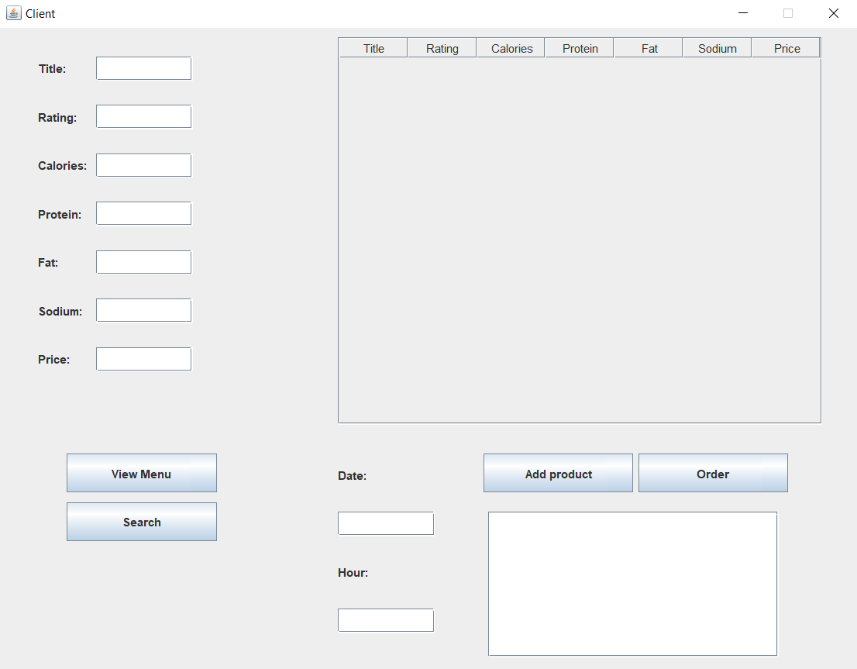

It extends the JFrame class and displays:
-7 text fields to search different items from the menu
-1 table where the client can see the menu
-1 button to view the menu, 1 button to search, 1 button to add product to an order, 1 button to order
-1 text field to introduce the date, 1 text field to introduce the hour
-1 text area to display the products that the client wants to order

ObserverInterface:
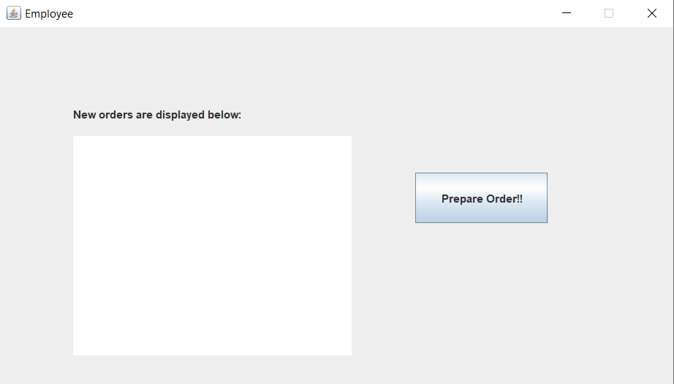
It extends the JFrame class and displays:
-1 text area where a message will appear each time a client orders something
-1 button that deletes the content from the text area when the employee receives the order and starts to prepare it

Implementation
The Main class has only one method, main, where we instantiate the view and initialize the controller, so
that the user can play with the application.
The BaseProducts, CompositeProduct and MenuItem classes are modelled after the Composite Design
Pattern. The composite pattern is meant to allow treating individual objects and compositions of objects, or “composites” in the same way. It can be viewed as a tree structure made up of types that inherit a base type, and it can represent a single part or a whole hierarchy of objects. The BaseProduct illustrates a simple product from the menu, the CompositeProduct illustrates a composed product which has multiple BaseProducts and they both extends the MenuItem class, which is the parent class and represents the structure of a menu item. In the CompositeProduct we will have a method computeValues() which calculates the new values for each parameter of an item of type CompositeProduct.
The NewDate class represents a class which contains the day, month and year that will help us to generate the date of the bill when a client ordered some items.
The User class represents a class where we store the username and password needed for a use to register and log in.
The DeliveryService class contains the methods that describe the actions that the client and the administrator can do:
-addMenuItem: with this method the administrator adds a product to the menu
-deleteMenuItem: with this method the adiministrator deletes a product from the menu
-modifyMenuItem: with this the administrator modifies an already existing product
-createOrder: with this method the client may create an order; also in this method we notify the observer about the order, by using the Observer Design Pattern
-generateReport1: generates a report containing the orders that were made between an interval of hour and will append the data to a text file
-generateReport2: generates a report that will show the repeated products and how many time they were repeated
-generateReport3: generates a report of the users that ordered multiple orders and the Orders that were over a specified price
-generateReport4: generates a report of the products that were ordered in a specified day and how many times they were ordered
In all these reports and some of the methods I used lambdas and streams. With streams and lambda expressions, you can create an assembly line. The assembly-line solution uses concepts from functional programming. The assembly line consists of several methods. Each method takes the data, transforms the data in some way or other, and hands its results to the next method in line.
The IdDeliveryServingProcessing interface represents the interface that will be implemented by the DeliveryClass, so all the methods in this interface are override by the DeliveryService class and described in the class, as specified before.
The Controller class makes the switches between the 4 interfaces, add action listeners to the specific buttons from the LoginInterface and also describes the way in which a user can register and login. In order to not have similar usernames, we will keep the username in a user.txt file and each time we create a new user we traverse that file to make sure that the username is not already taken.
The FileWriter1 class is a class containing a method which prints to a file the content of a bill, the order id, order date and the products that were ordered, also calculating the total price of the order.
The Serializator class has the methods serialize() and deserialize() which keep the information from the DeliveryService class in a file, in order to load it when we start the application again.
The AdminInterface class contains the components of the graphical interface for the admin. Here I also added the action listeners for the buttons on this graphical interface. For importing the products from the products.csv file I have the function readingFile() implemented in this class.
The ClientInterface class contains the components of the graphical interface for the client. Here I also added the action listeners for the buttons on this graphical interface. I have a method that uses lambdas and streams in order to search for a specific keyword in the menu.
The LoginInterface class contains the components of the main graphical interface.
The ObserverInterface class contains the components of the graphical interface for the employee.

Results
For the results for the 4 reports I generated 4 different text file that I will upload on GitLab. I also
generated a text file for the bill. The other results can be visible on the graphical interface, as they represent the consequences of the actions of the user.

This is how some reports look like:
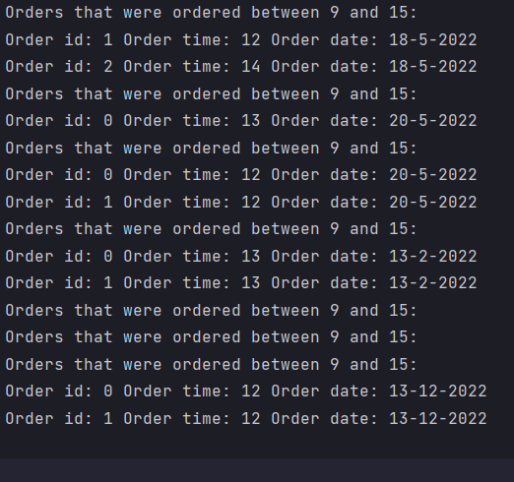
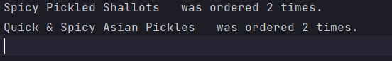
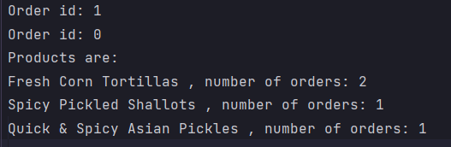

Conclusions
This project was a good exercise for improving OOP concepts and for improving the skills that I learned in the first semester of this year. I found it very challenging.
In the future, I would like to be more organized as I found out that having a good image of the project before starting to implement and write code and having the problem already organized in my mind and on paper helps a lot. It reduces time and work, and everything seems more clear and easier to work with. I also came to the conclusion that facing problems with your code and trying to solve them by yourself will obligate you to do a lot of research and you can learn better from it. After ending this project, I learnt better how to use different design patterns, how to write code using lambdas and streams and how easy they make the code to look and to work with. I also understood the importance of hashing and how to work better with a table on an interface.

Bibliography
- Object Oriented Programming – lectures of prof. Marius Joldos
- Programming Techniques – lectures of prof. Cristina Bianca Pop
- www.stackoverflow.com
- Bro Code – YouTube channel
- https://www.baeldung.com/
- https://app.diagrams.net/

